Instructions to update the fixture
- USB uploader and program software
1.1 USB uploader, see below,
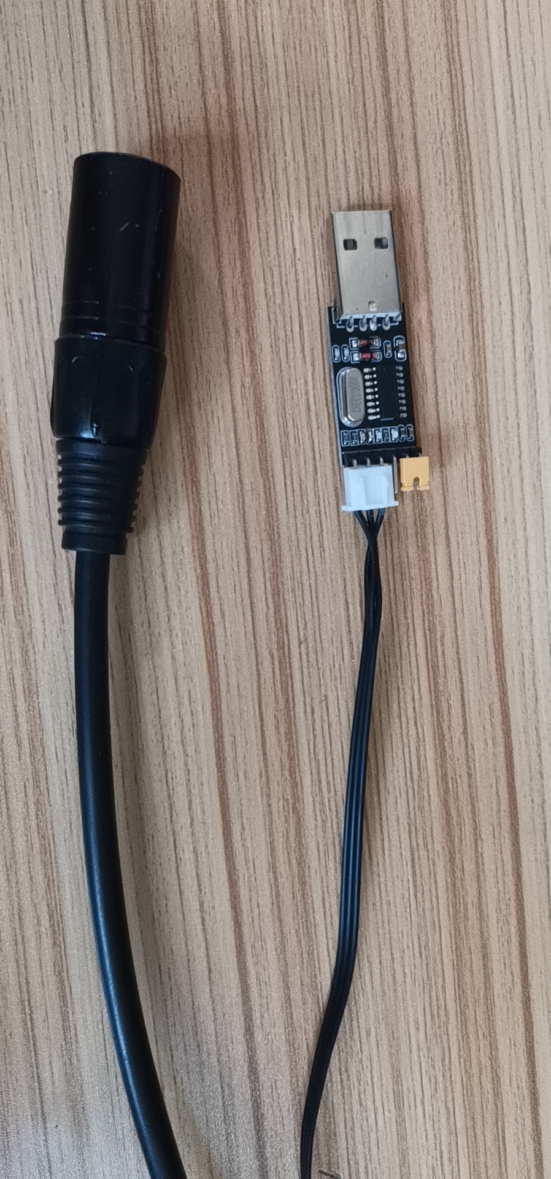
1.2 Connect the USB uploader with the computer (window system), open the “device manager”. If you’ve already install the driver software (see the instructions to install the driver.doc), you’ll see the “USB-SERIAL CH340 (COMXX)”. XX referes to the port number of the COM, it could be different in each computer. The current one in our computer is COM 5.

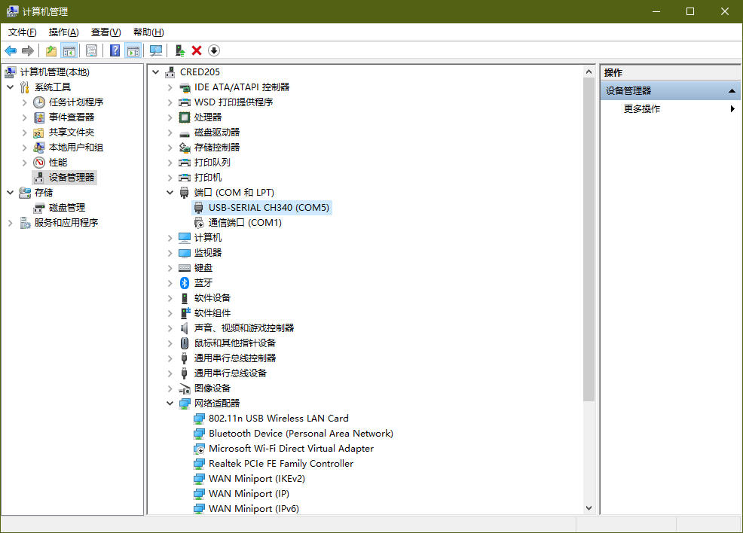
1.3 Install the software CHAUVE Program setup.exe, and then you’ll see the shortcut icon below,
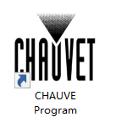
- Program software setting

  - Open the software program
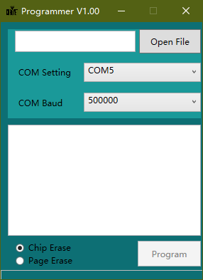
1
5
2
3
4
  - Check the box as above ( pay attention to the orders of each step)

- Step 1: Select the new software
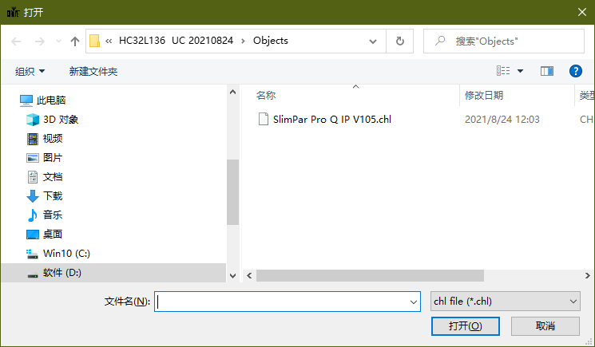
- Step 2: Choose the COM port number, it’s “COM5” in this computer
- Step 3: COM Baud, usually we’ll not change it and keep it as default. If the cable is too long, we can select a lower com baud.
- Step 4: Click Chip Erase
- Step 5: Start updating the fixture
- Updating the fixture
When you finished the setting as above 2.2 (step 1~4), Connect the fixture with the USB uploader via the DMX connector, and click button “Program” (step 5), then power on the unit, it will start updating the fixture. When finished the software updating, the fixture will automatically restart.
